CAREER SERVICES NEWSLETTER |  | April 12, 2021
PRESENTATIONS
NOAA – April 13 at 1100
CHP – April 13 at 1730
Caltrans – April 14 at 1730
The Pasha Group – April 15 at 1100
Caltrans – April 15 at 1730
MSC for Licensed Opps – April 20 at 0800 & 1000

Email Tess Luna if attending
Video Series on Career Topics  Life Skills for Graduating Seniors  Konnecting Keelhaulers  Last week of company presentations!!! We have included every presentation from the semester and the company’s bio and information linked under SPRING 2021 COMPANY INFORMATION.  Also, more internships and jobs are being posted on KCC, some seen on the right, every week. Remember, these are companies reaching out to Cal Maritime looking for our cadets.  If you have any questions about the above, please connect with career services via email or appointment!! |  | NEW ON KCC  Enterprise Holdings  Management Trainee Internship & Management Trainee  SSA Marine/Carrix  Superintendent - 2 positions  Inchcape Shipping Services  Ship Boarding Agent  Andros Engineering  Engineering Intern  The Pasha Group  Intern - Operations  CBRE - OHSU  Maintenance Tech Apprentice (FET Intern)  NextEra Energy, Inc  Production Tech  DoBe USA  Operation Assistant  Go to KCC and click the jobs and internships for more.  Meetings/Events  ST II - April 13th  Engineering Co-Op - April 15th

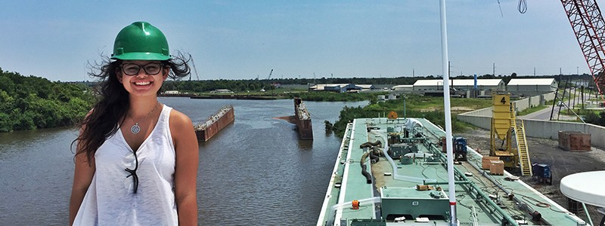
Thoughts on Persistence and Waiting

As the calendar turns to April soon, many of you are in the midst of searching for jobs and internships. By now you've probably sent out quite a few applications as well as reached out to and expanded your network, attended company presentations, and any other events that connect you to employers. As you continue to reach out to people and apply for positions, the waiting game commences to hear back from these various companies, firms, and organizations. This is, undoubtedly, a highly challenging part of the job and internship search process, as the situation leaves your
control and falls into the hands and timetables of others. There is always a question of what to do during this time. How do to handle the waiting game? A couple things you can do include continuing to apply for open positions and continue to take advantage of networking events. Until you accept an offer, there are always more positions to apply to, plus this proactive nature can give you a small sense of control in the situation. Networking is something that never has to stop, as the point isn't simply to use a connection to
obtain a position, but rather help you learn more about a field and career, while connecting you to people who can assist in your search. Other things you can do is speak with your resources on new places to look for openings, practice skills you will need for a position, and weigh the hierarchy of the positions you applied for, so when you are faced with a decision, you are ready to make the most informed one.

Tess Luna

Make a 1 on 1 with a career coordinator

Wendy Higgins Leora Hodes
whiggins@csum.edu lhodes@csum.edu
Tess Luna  tluna@csum.edu | Ryan Rodriguez  rrodriguez@csum.edu
csum.edu/career-center | Ryan Scheidemantle rscheidemantle@csum.edu

