CAREER SERVICES NEWSLETTER |  | April 26, 2021
Video Series on Career Topics Life Skills for Graduating Seniors Konnecting Keelhaulers  There have been a lot of new jobs posted on KCC in the last two weeks. If you haven't made an account to access them, please do ASAP. Not only will this serve you now, but your account stays with you as an alum. If you would like any help navigating the platform, please schedule an appointment with one of the career coordinators and we can explain the features and benefits in depth.  We are currently in the process of schedule more alumni interviews in our Konnecting Keelhaulers series, so be on the lookout for those to be posted. |  | NEW ON KCC  Flagship Management LLC  7 positions - Operations, Ship Repair, LNG Tech  Solano County  Public Works Trainee  Southwest Gas  Plant Technician/LNG  USDA Agricultural Research  General Engineer  Wonder Valley Ranch Resort  Houseboat Captain  Crowley Maritime  Data Business Analysis  Genentech  Senior Maintenance Mechanic  Monterey Bay Aquarium  Systems Operator 1  Inchcape Shipping Services  Ship Boarding Agent - Long Beach  Scout Clean Energy  Associate Project Developer  Affiliated Engineers  Commissioning Engineer Intern  Angel Island Tiburon Ferry Inc.  Deckhand/Sr. Deckhand  Sause Bros.  3 positions - Steward, Engineer, Mechanic  Pier 39 Marina  2 positions - Admin, Security  Go to KCC and click the jobs and internships for more.
If you need help with your job or internship search or prepping for interviews, please schedule an appointment. Especially with internships, there is still time to land one.

Meetings/Events
ST II - April 27th at 1100 and 1900

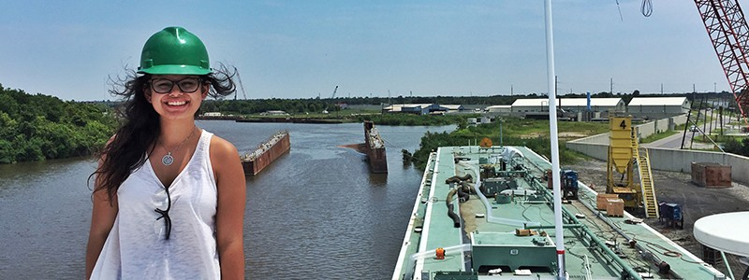
Thoughts on Weighing Offers

Recently, Career Services has fielded questions surrounding how to weigh multiple offers or what to do when you have an offer but are waiting to hear back from other employers. This can definitely be a challenging experience and sometimes cause unsettling feelings, as the unknown nature of making these decisions are almost always fraught with a tinge of anxiety. While you will never know what may have become of alternate timelines, taking time beforehand to consider a decision from multiple perspectives, discussing various options with your support system,
and understanding how you react to various unknowns can make the decision making process easier.
Remember, the goal isn't to make it easy, just easier. Having a thought out process in place beforehand will help, as we are prone to making rash and emotional decisions when we are caught off guard. Starting when you apply for different positions, mull over which ones you like more than others and why. When you land an interview, consider where that position is in your proverbial hierarchy and the various opportunities and perks
it offers you. This will help your decision process should you receive an offer. You can only make a decision with the information you have in that moment, and clearing up your decision making process can lead to greater peace of mind that you did everything you could to make the best decision.
Sometimes it will work out as foreseen, other times it won't, but making a decision after consultation and review can leave you with a more satisfied feeling.

Make a 1 on 1 with a career coordinator

Tess Luna

Wendy Higgins Leora Hodes
whiggins@csum.edu lhodes@csum.edu
Tess Luna  tluna@sum.edu | Ryan Rodriguez  rrodriguez@csum.edu
csum.edu/career-center | Ryan Scheidemantle rscheidemantle@csum.edu

