Newsletter from Career Services
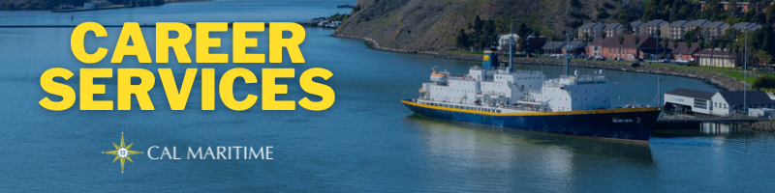
December 13th, 2021

Employer Spotlight - Astra
Astra is an aerospace engineering company located in Alameda in one of the old Navy hangars. Career Services has recently been in contact with them to develop a partnership around internships, jobs, and possible site visits. Astra has already posted 2 jobs on KCC they are looking to fill ASAP (hello December engineering grads) and plan on attending the Career Fair in March. They employ several Cal Maritime grads who have made a great name for the university and are eager to recruit more!

On the Website
We have added lists of past internship companies to our website. You will find them broken down by major with hyperlinks to each company or organization as well as the location a past Cal Maritime cadet has interned at. If you are wondering where to apply or looking for more ideas, check out the list that corresponds with your major.
Past Co-Op Hosts
Konnecting Keelhaulers has posted another employer interview with BAE Systems. Madeline Wren and Casey Tew run through the application process for BAE, what they look for on resumes and how to stand out, and ways to learn more about the company while at Cal Maritime.
BAE Systems Recruiters: CS Page, YouTube, Spotify, Anchor
Watch all Konnecting Keelhaulers on the CS Page and YouTube and Listen on Spotify and Anchor

Appointments & Walk Ins
Career Services highly encourages you to stop by our offices, located in the Student Services Building, next to the quad. We take both appointments and walk ins, depending on what works with you and our schedule. Appointments in person are encouraged, but we can accommodate appointments via Zoom if that is your style.
Schedule an Appointment

Advice Section – Resume Quick Tips
With the semester close to winding down, we wanted to take this moment to offer some resume quick tips as you think about applying for internships and jobs over the break and in spring. We wanted to highlight some various questions and consistent hiccups that we have seen in our office over the semester. The winter break is a great time to pull out your resume and polish it up with any new endeavors and responsibilities you’ve had over the past 6 months, or since you updated your resume last.
In terms of formatting, do not use a template that has 2 columns of information. This is an atypical style that recruiters are not used to reading which can cause them to skip over your resume or miss information. Resumes that are left aligned, like a typical essay, are industry standard, plus it has the benefit of following tested eye-tracking methods that ensures your information is where recruiters will look for it.
Two housekeeping things to double check are your email and whether you saved your resume as a single page or with a blank 2nd page. Make sure you are using an email that you check regularly and stay alert to your spam file or daily digest emails. Sometimes email responses from companies end up there instead of your regular inbox. When editing your resume, sometimes a 2nd page pops up. Make sure you move all information to one page and delete spaces on the 2nd, so it deletes.
When highlighting experience, remember that volunteer work, participation in various Corps of Cadets roles, projects and club membership all counts. Employers aren’t just interested in work experience and understand that you can build professional skills in a multitude of ways (check the employer interviews on Konnecting Keelhaulers). To this end, when writing bullet points for your experiences, make sure to include action, reason, and/or result for how and why you did a particular task. Many times, we see resumes only highlighting your task, but not how you went about completing it and the result of it. Employers want to see the whole process. And, finally, don’t copy a job description, come up with your own words. If you need help, swing by our offices and consult our career guide!

Career Services Meetings
Sea Training II Co-Op
Stay tuned for meeting dates in Spring Stay tuned for meeting dates in Spring

Networking Opps

Company Presentations
Amazon Web Services Virtual Event - Oregon 12/14 1600 – 1730 – Register Here

NEW ON KCC
FieldCore
Field Engineer - Intern
The Pasha Group
Operations Manager SF (Per Diem)
Calpine Corporation
2 Power Ops Intern
Lead Manager – Geysers
Plant Engineer III
CCA Billing Analyst
Senior Business Intelligence Developer
Flagship Management LLC
15 Positions
Vistra Energy
Control Room Operator
Wilson Albers
Port Engineer
Monterey Bay Aquarium
Facilities Systems Supervisor (Day and Night Shifts)
Systems Operator I
Matson
Fleet Maintenance Manager
Sr Vessels Manager
Allianz Global Corporate & Specialty
Senior Risk Consultant – Marine – Remote
ArcBest
Management Trainee
Find more jobs
Find more internships

Make a 1-on-1 with a Career Coordinator
Ryan Rodriguez
rrodriguez@csum.edu
Ryan Scheidemantle rscheidemantle@csum.edu
Director
Lily Ploski
lploski@csum.edu
Admin Assistant
Tess Luna
tluna@csum.edu

Career Services
California State University Maritime Academy

