Newsletter from Career Services
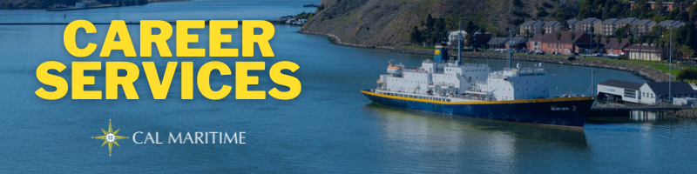
February 7th, 2022

Employer Spotlight – Johnson Controls
Johnson Controls is a company that specializes in efficiency, controls, and automation of fire, HVAC, and security equipment for buildings. They have long been an employer partner of Cal Maritime, recruiting both for full-time and internship positions over the years and employing multiple alums. They will be at the career fair in March and have current open internship positions for intern engineers in San Francisco and Sacramento and will be looking to recruit business students for a project management team at the career fair.

On the Website
To request a workshop, presentation, or panel for you class, club, or any other group of interest, please check out our newly created campus services request webpage. We can provide education and resources on resumes, job/internship searches, career plans, LinkedIn/networking, and more. If you have something in mind, don’t hesitate to fill out our request form.
Campus Services
Konnecting Keelhaulers recently interviews double alum Max Rosenberg who currently works a Port Engineer for The Vane Brothers Company. Check it out to learn about his career path in the tug industry and how both his bachelor’s in ME and master’s in Transportation and Engineering Management helped his career.
Watch all Konnecting Keelhaulers on the CS Page and YouTube and Listen on Spotify and Anchor

Appointments & Walk Ins
Career Services highly encourages you to stop by our offices, located in the Student Services Building, next to the quad. We take both appointments and walk ins, depending on what works with you and our schedule. Appointments in person are encouraged, but we can accommodate appointments via Zoom if that is your style.
Schedule an Appointment

Advice Section – Job Search
While it feels good to sit down and begin your job or internship search with exactly what you want to do in mind, many times this isn’t the case. Often, you might have some vague idea or little idea at all of what is out there or what you are interested in. This, no doubt can produce some stress, but there are several paths you can take to help clear up your thought process.
In this section, we have discussed networking through LinkedIn, with peers and professors on campus, through your personal and professional networks, and via events on campus. Those are great ways to be proactive in your searches and help set you up with resources and information to land that job or internship you seek.
Another tool to add to your process is jumping on to industry job boards, third party aggregators such as LinkedIn and Indeed, or company specific career pages. Searching for and looking through job descriptions of various positions can help you better understand what employers are looking for and find where you interests and personality intersect with positions. As you start to better understand job postings, this will help you more quickly filter through positions as you continue your search.
Further, this will help you learn about new firms, organizations, and positions that within your areas of interests that can open up new doors for you to explore. By doing this, you can begin to narrow the focus of your search that will help when you start applying, as well as when you have networking conversations. From there, progress becomes easier and clearer, which makes it easier to continue your progress. If you do have any questions about how to get this process started, head over to the internship/job search workshop held weekly in Lab 101 at 1400.

Career Services Meetings
Sea Training II Co-Op
2/17 – 1100 – Rizza Engineering 2/17 – 1100 – Peachman
Cadet Panel IBL 2/22 – 1100 – Peachman
GSMA 2/24 – 1100 – Peachman

Workshops
Internship/Job Search – 1400 – Lab 101
Resume/Cover Letter – 0900 – Lab 101

Networking Opps

Company Presentations
Chubb Risk Engineering 2/10 – 1100 – Zoom
Peace Corps Service Panel 2/10 – 1200 – Register Here
Critical Arc 2/16 – 1730 – Zoom

NEW ON KCC
Modern Sailing
Fleet Services Specialist
Sealift Inc.
Third Assistant Engineer/Third Officer
City and County of San Francisco
2022 Summer Student Intern
Flagship Management LLC
18 Positions
Calpine Corporation
Administrative Assistant II (Analyst)
Hudson Institute
Hudson Institute Political Studies 2022 Summer Fellowship
Resolve Marine Group
Chief Engineer
BioMarin
Sr. Instrumentation Technician (Days)
Instrumentation Technician 2
Kirby Marine
Assistant Engineer
ABF Freight System
Inbound Operations Supervisor
BioMed Realty
Facilities Coordinator
Worley Group
Plant Operating Engineer
Johnson Controls
Controls System Engineer (Intern)
Find more jobs
Find more internships

Make a 1-on-1 with a Career Coordinator
Ryan Rodriguez
rrodriguez@csum.edu
Ryan Scheidemantle rscheidemantle@csum.edu
Director
Lily Espinoza
lploski@csum.edu
Admin Assistant
Tess Luna
tluna@csum.edu

Career Services
California State University Maritime Academy

