Newsletter from Career Services
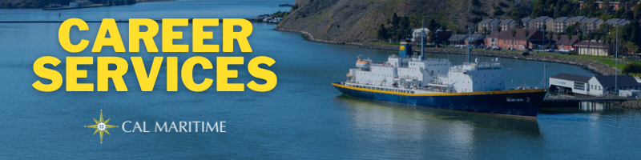
January 10th, 2022

Employer Spotlight – Inchcape Shipping Services
Inchcape Shipping Services is a longtime employer partner with Cal Maritime. They offer port agency services, with offices in Richmond, Long Beach, and many more locations. They recruit from Cal Maritime for both internships and full-time positions. Inchcape has recently posted an Operations Support Specialist position on KCC and will be attending the Career Fair in March.

On the Website
We have added lists of past internship companies to our website. You can find these broken down by major with hyperlinks to each company or organization as well as the location a past Cal Maritime cadet has interned at. If you are wondering where to apply or looking for more ideas, check out the list that corresponds with your major.
Past Co-Op Hosts
Konnecting Keelhaulers interviewed Mechanical Engineer alum Darlene Conolly right before the winter break. Darlene found her way to Cal Maritime as a post baccalaureate when she decided to combine her interest in math and love of the sea. Post-graduation, she worked with Amber Kinetics, an energy storage company, before transitioning to a new role with Pillar Point Harbor this month.
Darlene Conolly: CS Page, YouTube, Spotify, Anchor
Watch all Konnecting Keelhaulers on the CS Page and YouTube and Listen on Spotify and Anchor

Appointments & Walk Ins
Career Services highly encourages you to stop by our offices, located in the Student Services Building, next to the quad. We take both appointments and walk ins, depending on what works with you and our schedule. Appointments in person are encouraged, but we can accommodate appointments via Zoom if that is your style.
Schedule an Appointment

Advice Section – Weighing Options
With the spring semester beginning, most of campus will also have one eye to the summer. Whether you are preparing to go on Commercial Cruise, looking for a Co-Op, or looking for a job, there will be some decisions that you have to make concerning what to apply for and, eventually, what to accept.
These decisions can be challenging, chiefly because you won’t always have the information for every opportunity you desire all at the same time. When it comes to looking for jobs and internships, the flow of applications, interviews, and offers are typically staggered. The companies or organizations are operating on their timeline, which, unfortunately, rarely overlaps with each other. Because of this, decisions become more difficult.
To help in your process, begin now to target not only companies or organizations and jobs or internships you would like, but also location, salary, type of work, and more. When thinking about your career, there are many factors that go into this decision, and they are different for everyone. Self-exploration of interests, values, and goals will help you weigh all of these factors and find out which are more important than others. Further, these interests, values, and goals are not static and can even change depending on the various opportunities you are pursuing. While this may feel like a daunting task, there are many resources that you can use to help you through this process.
By no means is it always easy to target your interests, values, and goals, and many times even more difficult to know about an organization or position just from reading about it online. You can utilize Career Services to speak with a career coordinator about your various questions, we have had to go through similar process. Beyond that, friends, family, mentors, and faculty on campus can provide insight as well. Utilizing your full network of resources, the people that know you best and others who have specific knowledges, can help shine light on blind spots and use probing questions to form new answers. Do not mistake this for making the process easy, as there will continue to be uncertainty and anxiety tied to some of these choices, but being proactive gives you a better chance of making a decision that fits your desires.

Career Services Meetings
Sea Training II Co-Op
Stay tuned for meeting dates in Spring Engineering 1/20 – 1100 Peachman
Also offered via Zoom
IBL/GSMA/OCN 1/20 – 1130 Peachman
Also offered via Zoom

Networking Opps

Company Presentations
Stay tuned for presentation announcements via email and on the CS Events page
Presentations will begin in February

NEW ON KCC
Starlight Marine Services
Engineer
Kirby Inland Marine
Assistant Engineer
AB
10ure Maritime
100/200/500 GT w DP/ Captain
Able Bodied/AB (Towing Experience)
Flagship Management LLC
17 Positions
Tidewater
Dispatch Relief Specialist
Inchcape
Operations Support Specialist
AET Offshore Services
Able Seafarer (AB)
Cabras Maritime Corporation
Tugboat Captain (MOT 500GRT)
Engineer Positions
Assistant Port Engineers
Promaxo Inc
Supply Chain/Operations Intern
Find more jobs
Find more internships

Make a 1-on-1 with a Career Coordinator
Ryan Rodriguez
rrodriguez@csum.edu
Ryan Scheidemantle rscheidemantle@csum.edu
Michelle Lewis
mlewis@csum.edu
Director
Lily Ploski
lploski@csum.edu
Admin Assistant
Tess Luna
tluna@csum.edu

Career Services
California State University Maritime Academy

