CAREER SERVICES NEWSLETTER |  | May 10, 2021
Video Series on Career Topics Life Skills for Graduating Seniors Konnecting Keelhaulers  There have been a lot of new jobs posted on KCC in the last two weeks. If you haven't made an account to access them, please do ASAP. Not only will this serve you now, but your account stays with you as an alum. If you would like any help navigating the platform, please schedule an appointment with one of the career coordinators and we can explain the features and benefits in depth.  Open During Summer  Career Services is open during the summer and will continue with appointments via Zoom. If your Co-Op or job search takes you into the summer, please reach out to us. Our services extend to alums as well, so if you are graduation, don’t hesitate to reach out as well. |  | NEW ON KCC  JLL  Lead Engineer & Engineer II  Linblad Expeditions  Seasonal Deckhand & Engine Mechanic  Harvey Gulf International Marine, LLC  Maritime Licensed Postions  Flagship Management, LLC  14 positions – Engineering, Business Development, Deckies  CMA-CGM America  Regional Alaska Safety Compliance Officer  National Cargo Bureau, Inc  Marine Cargo Surveyor  NYC Dep. Of Transportation  Marine Oiler  Skywalker Holdings, LLC  Construction Administrator (Temp)  Bay Breeze Charters  50-100 Ton Master w/ Sail Endorsement  Marine Group Boatworks  Project Manager  LightRiver  Associate Optical Field Engineer  Alcatraz Cruises  Island Facilities Manager  Metro Ports  Summer Intern  Fortis Construction  2 positions – Project Engineer  Go to KCC and click jobs and internships for more.

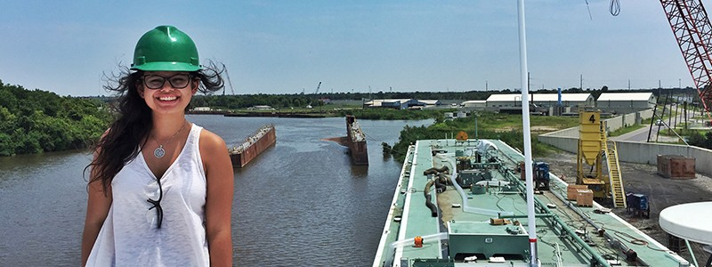
Thoughts on Weighing Offers

Recently, Career Services has fielded questions surrounding how to weigh multiple offers or what to do when you have an offer but are waiting to hear back from other employers. This can definitely be a challenging experience and sometimes cause unsettling feelings, as the unknown nature of making these decisions are almost always fraught with a tinge of anxiety. While you will never know what may have become of alternate timelines, taking time beforehand to consider a decision from multiple perspectives, discussing various options with your support system,
and understanding how you react to various unknowns can make the decision-making process easier.
Remember, the goal isn't to make it easy, just easier. Having a thought-out process in place beforehand will help, as we are prone to making rash and emotional decisions when we are caught off guard. Starting when you apply for different positions, mull over which ones you like more than others and why. When you land an interview, consider where that position is in your proverbial hierarchy and the various opportunities and perks
it offers you. This will help your decision process should you receive an offer. You can only make a decision with the information you have in that moment and clearing up your decision-making process can lead to greater peace of mind that you did everything you could to make the best decision.
Sometimes it will work out as foreseen, other times it won't, but making a decision after consultation and review can leave you with a more satisfied feeling.

Make a 1 on 1 with a career coordinator

Tess Luna

Wendy Higgins Leora Hodes
whiggins@csum.edu lhodes@csum.edu
Tess Luna  tluna@sum.edu | Ryan Rodriguez  rrodriguez@csum.edu
csum.edu/career-center | Ryan Scheidemantle rscheidemantle@csum.edu

