Newsletter from Career Services
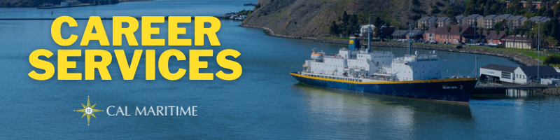
November 1st, 2021

Networking & Dining Etiquette Dinner – November 4th
On November 4th, Career Services will be hosting a return of the Networking & Dining Etiquette Dinner. This will be held in the Compass Room from 1700 – 1900. This is an opportunity for cadets to practice their networking skills, while taking part in a business formal dinner. Dress for the event will be salt and peppers or business attire.

On the Website
If you still need to follow up with the companies or organizations you spoke with at the Career Fair, you can utilize the 2021 Fall Career Fair program to find the representatives and their contact information. Follow ups are a great way to begin building your professional network and stay on the company or organization’s radar.
Fall 2021 Career Fair Program
Over the past week, Career Services has interviewed an alum from our Master’s in Transportation and Engineering program, and two recruiters from BAE Systems. Nicole Light Densberger discusses how she found Cal Maritime’s master’s program and her work that combines air pollution, the maritime and transportation industries. Madeline Wren and Casey Tew run through what BAE Systems highlight what the company looks for on resumes and applications and providing insight on what cadets can do while in college to prepare them for opportunities with BAE.
Watch Konnecting Keelhaulers on the CS Page and YouTube

Appointments & Walk Ins
Career Services highly encourages you to stop by our offices, located in the Student Services Building, next to the quad. We take both appointments and walk ins, depending on what works with you and our schedule. Appointments in person are encouraged, but we can accommodate appointments via Zoom if that is your style.
Schedule an Appointment

Advice Section – Early Offers
With November arriving on the calendar, we are approaching the time when some companies will begin to send out offers for summer internships and billets, as well as postgraduate, full-time positions. This can cause some anxiety, as many of these early offers arrive before there you know what the rest of the landscape entails. Having to decide before you have all the information that you would like is rarely fun, but sometimes that is how it goes in the employment market.
To help quell some of these anxieties (they are impossible to eradicate, especially when dealing with big decisions and new endeavors), we want to offer some best practice ideas. From the moment you have an employment discussion with a company or organization, send in a resume, or complete an application, begin thinking about the prospect of following through and accepting and offer. This entails considering what your wants are from a position and employer early on, allowing you to put positions into tiers as you converse with employers and apply for positions. Where does this company/position land in my hierarchy? Does it provide the overall skills and training I am looking for? How would this fit into my broader career goals?
These are the types of questions to ask yourself early on, so you don’t feel all the pressure of accepting or declining an offer once you receive it. If these questions are difficult to answer, stop by Career Services to discuss them or speak with peers and professors who can provide insight to both positions and companies. Utilizing the resources here on campus can help you sort through potential decisions before you are faced with them, allowing you to clear up some of your thinking when the time comes for a decision.
This is not to say these decisions will become easy. You might get an offer from a company you like while still waiting for one you love. These are the difficult decisions common when looking for employment. In the end, only you can make that final decision, whether to hold out or accept what you have in the moment. For ST II or internships, remember your position is only for a short time with the main goal of gaining experience. Even if it isn’t that dream opportunity, you will be get your credit and learn valuable professional skills to take with you into postgraduation. If it is a full-time job, remember you are not locked into it forever. Talk with Career Services and professors, many of whom have made position and career changes for advice.

Career Services Meetings
Sea Training II
November 16, 1100 – Rizza

Networking Opps

Company Presentations
Delaware River Bay Authority 11/2 1100 – Link
UPS Buildings and Systems Engineer – 11/9 1100 – Room TBA
Networking & Dining Etiquette Dinner 11/4 1700 – 1900

NEW ON KCC
Bath Iron Works
Professional Development Program
2022 Summer Internship Program
Seiden Krieger Associates
QSSE Manager (CMA-CGM Terminals)
Calpine Corporation
Power Ops Rotation Engineer
2 Power Ops Intern
CCA Operations Specialist
US Army Corps of Engineers
Lock and Dam Operator (Temp)
Ocean Network Express
Specialist, Vessel Container Transportation
smart-Tecs LLC
Manufacturing Engineering Coordinator (PT)
Defense Contract Audit Agency
Pathways Interns (Auditing)
California State Lands Commission
Marine Safety Inspector
California Air Resources Board
Freight Approvals Engineer
City and County of San Francisco
Stationary Engineer, Juvenile Probation
Southland Industries
Design Engineer Intern
Project Engineer Intern
Find more jobs
Find more internships

Make a 1-on-1 with a Career Coordinator
Ryan Rodriguez
rrodriguez@csum.edu
Ryan Scheidemantle rscheidemantle@csum.edu
Director
Lily Ploski
lploski@csum.edu
Admin Assistant
Tess Luna
tluna@csum.edu

Career Services
California State University Maritime Academy

