Newsletter from Career Services
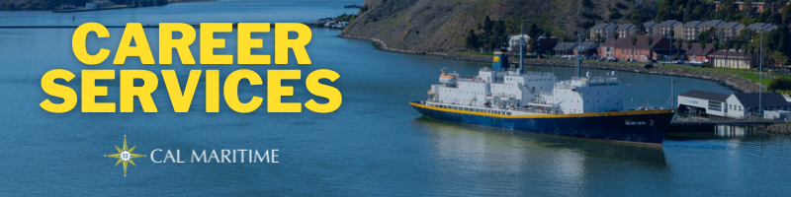
November 15th, 2021

Keelhauler Career Connect
Keelhauler Career Connect, aka Purple Briefcase, has seen an influx of both jobs and internships over the last 2 weeks. In that short time, almost 50 positions have been posted, including companies looking to get an early start on internship recruiting. Some of these positions even include part time work during the spring semester. It might seem like far away until you can begin working, but companies are already on the lookout for candidates.

On the Website
If you still need to follow up with the companies or organizations you spoke with at the Career Fair, you can utilize the 2021 Fall Career Fair program to find the representatives and their contact information. Follow ups are a great way to begin building your professional network and stay on the company or organization’s radar.
Fall 2021 Career Fair Program
Make sure to check out MS-TEM alum Nicole Light Densberger’s interview where discusses how she found Cal Maritime’s master’s program and her work that combines air pollution, the maritime and transportation industries. Also, stay tuned for newly recorded interviews with recruiters from BAE Systems and MSC that will be posting soon.
Watch Konnecting Keelhaulers on the CS Page and YouTube

Appointments & Walk Ins
Career Services highly encourages you to stop by our offices, located in the Student Services Building, next to the quad. We take both appointments and walk ins, depending on what works with you and our schedule. Appointments in person are encouraged, but we can accommodate appointments via Zoom if that is your style.
Schedule an Appointment

Advice Section – Research
Sometimes in Career Services, we speak with cadets who have variations of the question, “What can I do with company X” or “do any companies in this area do X?” The typical nexus of questions like this is when cadets are unsure of what they would like the next step in their career process to look like whether it is job type or location.
It can be daunting to face this alone, which is why Career Services is available to you to leverage the professional networks and connections that have been built over the years. Starting out by utilizing our office, in addition to other staff and faculty can get you kick started on being able to answer the above questions and others like it. However, simply answering those base questions are only the beginning.
When it comes down to it, now one else on campus but you can answer the more intimate details of what you might want your career to look like and the places, both organizationally and location wise you’d like to work. This is where doing your own research comes into play. Yes, asking questions of mentors, staff, faculty, and professional network can get you started, but diving into company pages, job descriptions, career outlooks, and the like on your own will prove invaluable. From here, you can find answers to some of your burning questions, come up with new questions to ask your network, and realize that you have the power to start shaping your future.
Some various places to start your research process are the aforementioned company pages and job descriptions, as well as looking at job postings on industry job boards and indeed.com. You can pull up glassdoor.com which has company profiles and reviews as well as salary and interview information. Expanding your network on LinkedIn can expose you to news articles and research in the fields you are interested in. If you want to learn more about the skills, knowledges, and activities of a particular career, check out O*Net which provides these plus salary info and short videos explaining what various careers do. Armed with your own research, it will help you have more meaningful job searches, career conversations, and networking conversations.

Career Services Meetings
Sea Training II
December 7, 1100 – Rizza
December 9, 1100 – Rizza (MSC only)

Networking Opps

Company Presentations
Peace Corps 12/2 1100 – Link

NEW ON KCC
SSA Marine
Environmental and Sustainability Intern
Toyota
2022 Vehicle Logistics Summer Internship Program
Calpine Corporation
Power Ops Rotation Engineer
2 Power Ops Intern
CCA Operations Specialist
General Steamship Corp Ltd
Vessel Manager/Boarding Agent
City & County of San Francisco
Stationary Engineer
Saildrone
Vehicle Operations Technician
Final Assembly Technician
Defense Contract Audit Agency
Pathways Interns (Auditing)
Kirby Inland Marine
Assistant Engineer
AB
Matson Navigation
Crewing Department Support Intern
Transmarine Navigation Corporation
Ship Agent
Starr Insurance Companies
Starr Global Associates Program
Crowley Shipping
Assistant Engineer (Ocean Class)

Find more jobs
Find more internships

Make a 1-on-1 with a Career Coordinator
Ryan Rodriguez
rrodriguez@csum.edu
Ryan Scheidemantle rscheidemantle@csum.edu
Director
Lily Ploski
lploski@csum.edu
Admin Assistant
Tess Luna
tluna@csum.edu

Career Services
California State University Maritime Academy

