Newsletter from Career Services
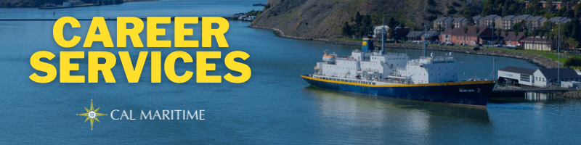
November 29th, 2021

December Career Action
With classes ramping up in December and most companies and organizations taking a pause in recruiting, you can still do some career work. Use a study break to peruse company websites or job boards to find new or interesting information that you can use when you ramp up applications in the spring.

On the Website
We have added lists of past internship companies to our website. You will find them broken down by major with hyperlinks to each company or organization as well as the location a past Cal Maritime cadet has interned at. If you are wondering where to apply or looking for more ideas, check out the list that corresponds with your major.
Past Co-Op Hosts
Konnecting Keelhaulers has recently recorded and posted two new episodes. One was with two MSC recruiters breaking down their application process and evaluation criteria for various positions. The other was with alum Alejandro Salgado, who has transitioned from maritime operations to journalism, covering supply chain, in the last three years.
MSC Recruiters: CS Page, YouTube, Spotify, Anchor
Alejandra Salgado, IBL ’17: CS Page, YouTube, Spotify, Anchor
Watch all Konnecting Keelhaulers on the CS Page and YouTube and Listen on Spotify and Anchor

Appointments & Walk Ins
Career Services highly encourages you to stop by our offices, located in the Student Services Building, next to the quad. We take both appointments and walk ins, depending on what works with you and our schedule. Appointments in person are encouraged, but we can accommodate appointments via Zoom if that is your style.
Schedule an Appointment

Advice Section – Trainee/Development Programs
A question we get a lot in Career Services centers around “What if I still don’t know exactly what I want to do when I graduate?” While it can feel like you are the only person who feels this way, this is a more prevalent thought than you might think. Even after completing your studies and internship, it can still feel like you don’t have a great grasp of exactly what you would like to devote 40+ hours to.
The good thing for you are companies and organizations recognize this and quite a few have programs in place that help answer this pressing question. Some offer specialized training programs within one discipline to help you augment and grow your skills you gained from Cal Maritime. Others offer rotational programs within a specific department(s) that teach you the ins and outs of the department(s) and what it takes to succeed, before placing you in a specific role. Lastly, some organizations will run people through full rotational programs, cycling through many departments, allowing an employee to sample and learn about many parts of the organization. Upon completion, there is typically a period to apply for specific departments you enjoyed.
These types of programs run various time lengths, some for about 2-3 months to others 18-24 months. Those focusing on a specific position tend to be shorter with a transition into that position upon completion. The longer rotational programs tend to be focused on training employees to take some sort of management role upon completion.
Some companies and organizations that typically recruit from Cal Maritime that offer programs like these include: ArcBest/ABF Freight, Wrist Ship Supply, General Dynamics NASSCO and Bath Iron Works, Crowley Maritime (shoreside), and Enterprise Holdings. A new company recruiting Cal Maritime, Starr Insurance Companies, is looking to recruit interested seniors into their marine underwriting program. Come speak with Career Services to learn more about these and other similar opportunities.

Career Services Meetings
Sea Training II
December 7, 1100 – Rizza
December 9, 1100 – Rizza (MSC only)

Networking Opps

Company Presentations
Peace Corps 12/2 1100 – Register Here

NEW ON KCC
Ports America
Terminal Optimization Manager
Helix Energy Solutions
QMED
2nd Assistant Engineer
3rd Assistant Engineer
Calpine Corporation
2 Power Ops Intern
Project Manager – Process Engineering Carbon Capture
Oceaneering
Quality Assurance Planner
Quality Control Engineer
Mechanical Technician
Training Qualification and Safety Specialist
Caltrol
Field Service Technician
Saildrone
Vehicle Operations Technician
Kirby Inland Marine
Assistant Engineer
AB
IHI Power Services Corp
Energy Storage Specialist
Astra
Launch Engineer
Test Engineer
Starr Insurance Companies
Starr Global Associates Program
Find more jobs
Find more internships
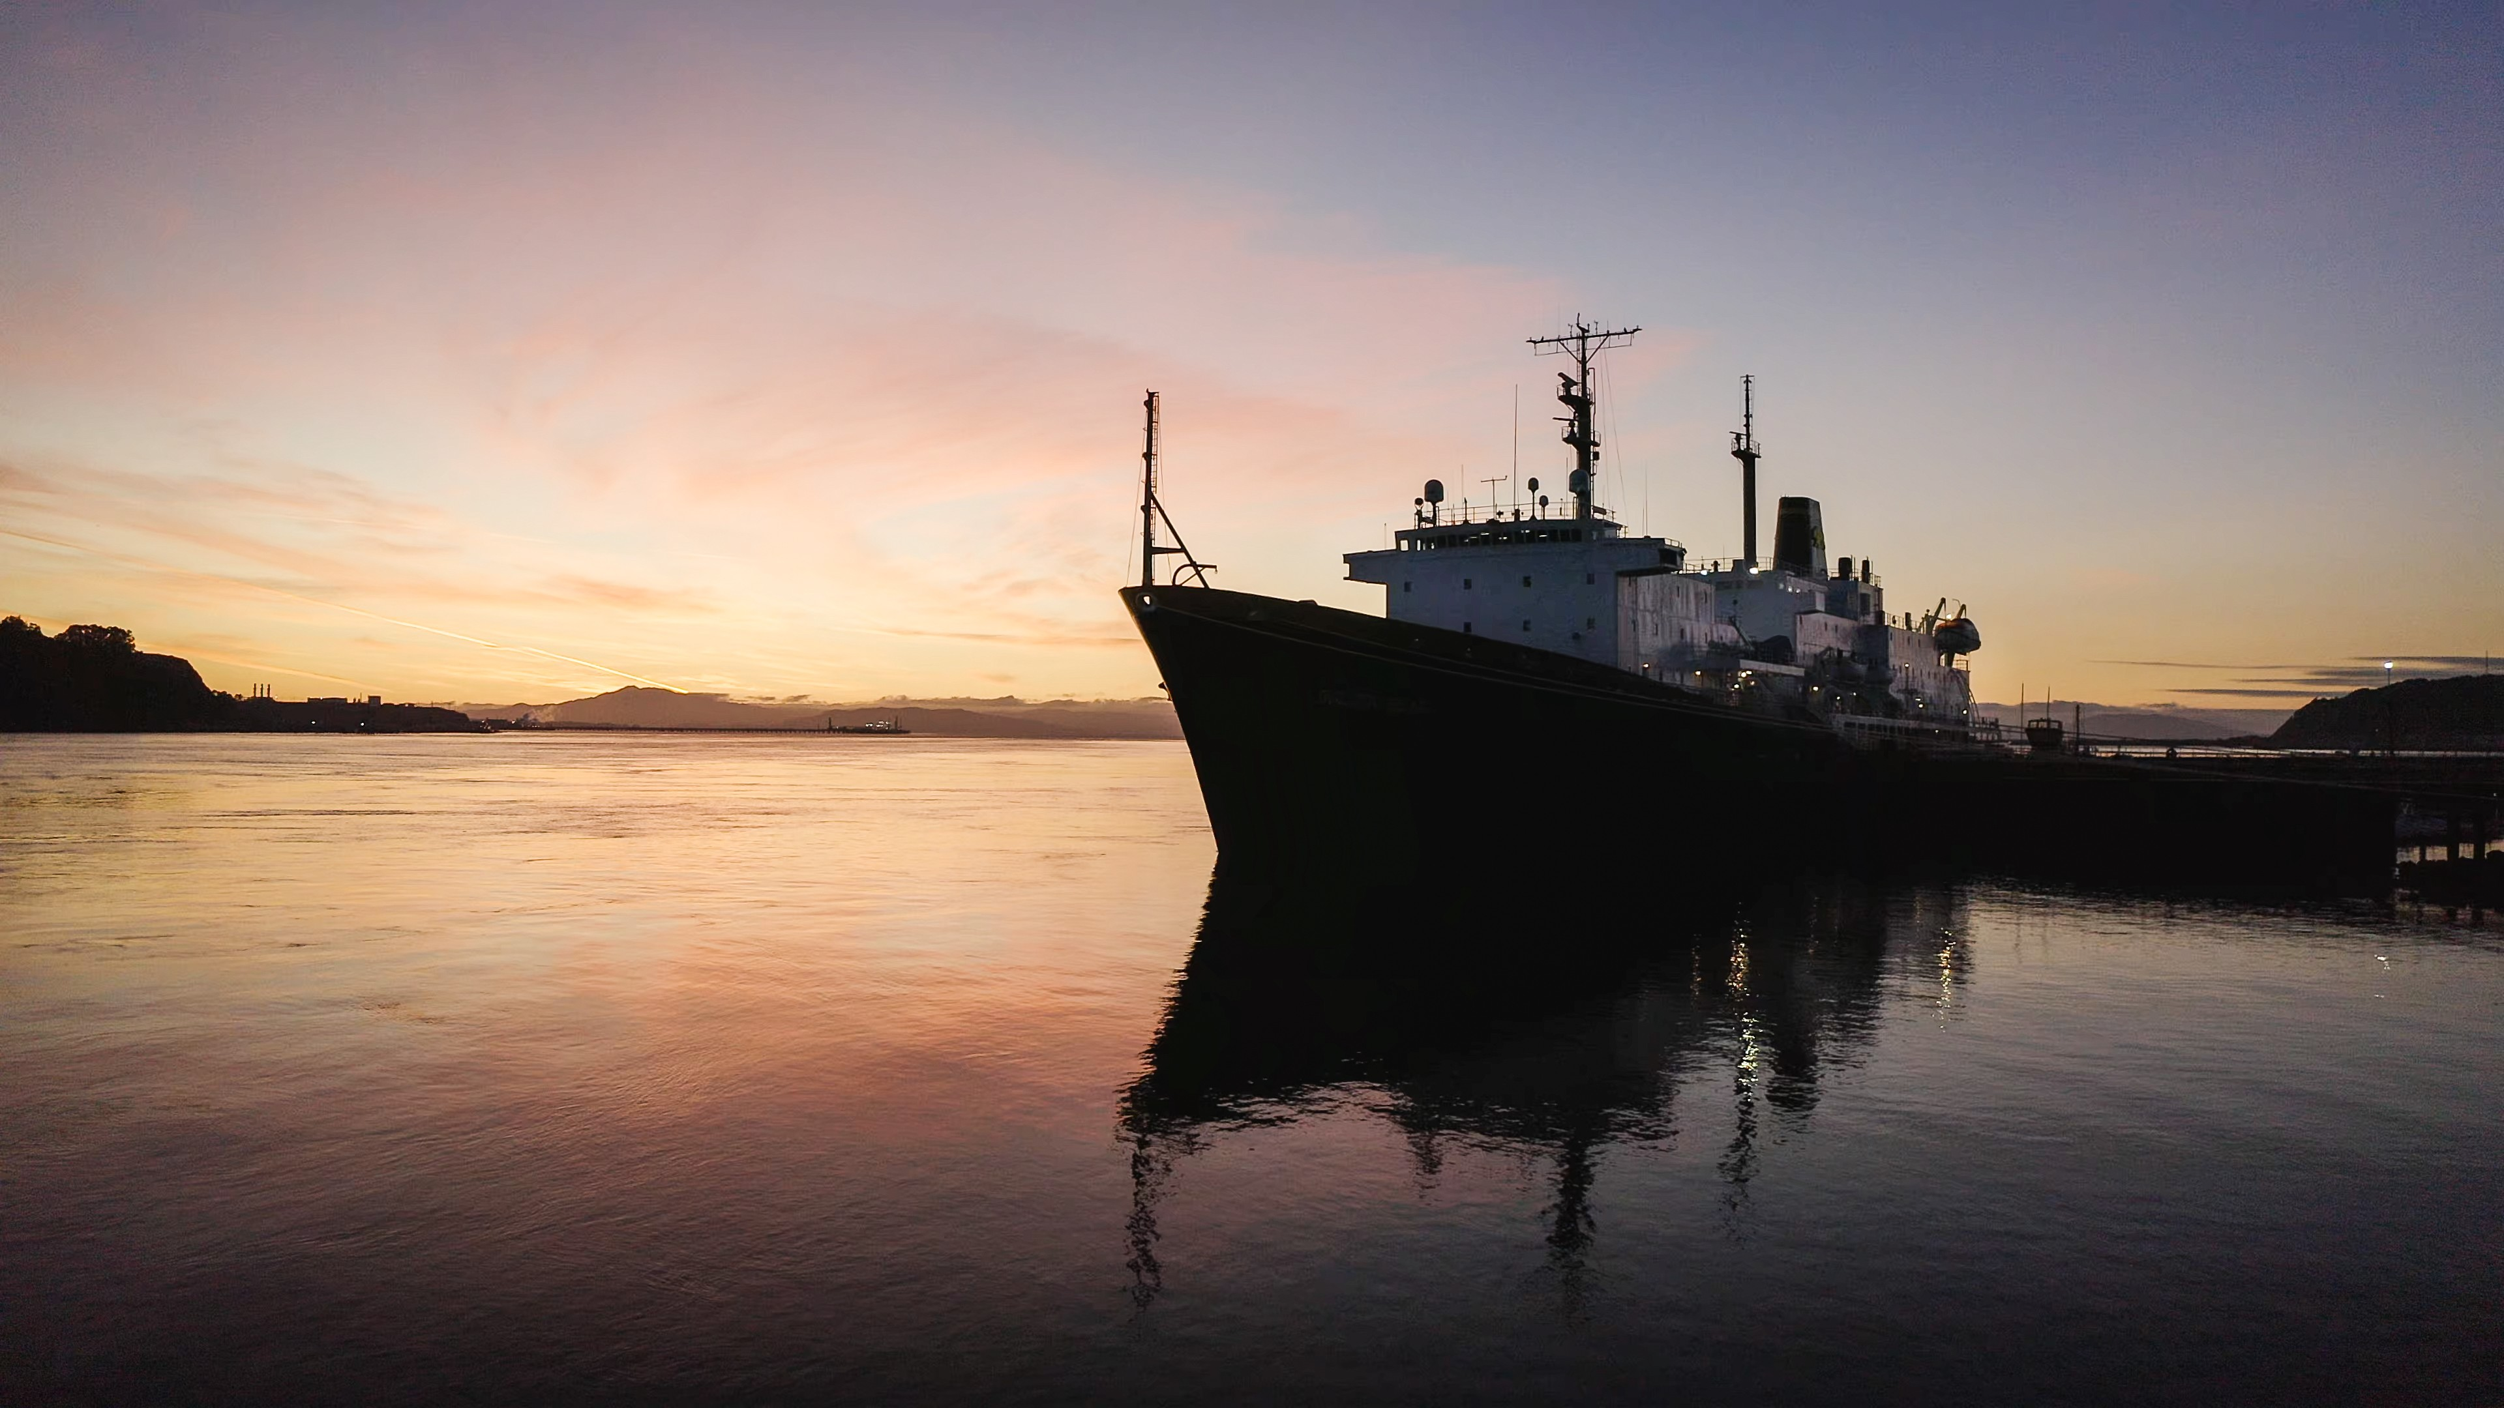

Make a 1-on-1 with a Career Coordinator
Ryan Rodriguez
rrodriguez@csum.edu
Ryan Scheidemantle rscheidemantle@csum.edu
Director
Lily Ploski
lploski@csum.edu
Admin Assistant
Tess Luna
tluna@csum.edu

Career Services
California State University Maritime Academy

