Newsletter from Career Services
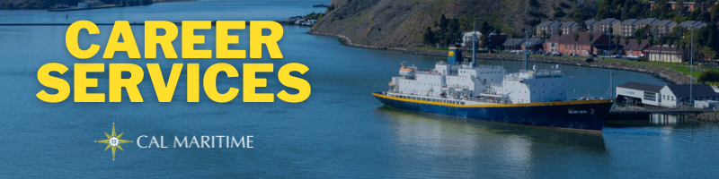
October 18th, 2021

Networking & Dining Etiquette Dinner – November 4th
On November 4th, Career Services will be hosting a return of the Networking & Dining Etiquette Dinner. This will be held in the Compass Room from 1700 – 1900. This is an opportunity for cadets to practice their networking skills, while taking part in a business formal dinner. The initial spots are reserved for 1/C and 2/C cadets, please get in touch with Career Services if you are interested in signing up.

On the Website
Career Services is either hosting or partnering with several companies or organizations for presentations over the next few weeks. Please check out calendar of events on our webpage to see who, when, and where companies and organizations will be presenting.
Calendar of Events
Over the last month, Career Services interviewed cadets who completed their Co-Op this summer. The following majors had cadets interviewed: GSMA, ME, FET, IBL, and Oceanography. Watch these interviews to learn more about the various experiences and options available. Be on the lookout for new interviews with industry partners and alumni dropping soon.
Watch Konnecting Keelhaulers on CS Page and YouTube

Appointments & Walk Ins
Career Services highly encourages you to stop by our offices, located in the Student Services Building, next to the quad. We take both appointments and walk ins, depending on what works with you and our schedule. Appointments in person are encouraged, but we can accommodate appointments via Zoom if that is your style.
Schedule an Appointment

Advice Section – Confidence
In the course of the many interactions Career Services has with cadets, one thing that consistently pops up are questions on how to convey skills, abilities, experiences, and interests. When thinking about your past, it can sometimes be easy to forget all the things you have done or discount something as “not really mattering.” When this happens, it can bleed into the networking conversations you have and feel you leaving as if you don’t have much to talk about.
Stopping by Career Services to work on your resume, discuss your past experiences, and the message you want to convey are great ways to start building your confidence for these situations. Numerous times, we have been told by cadets after working through their resume, “Wow, I didn’t realize that I had done this much in my past. I feel way more confident now speaking with industry professionals.” This also happens through the course of conversations on skills and interests. Being able to work through your thoughts with another person helps you craft a more coherent and polished message, leaving cadets feeling confident in approaching these networking conversations.
Remember, a core mission of Career Services is to help you on your career path, to the point that you feel confident traversing it on your own. We are ready to help you go beyond simply writing a cover letter or resume, practicing interview answers, or telling you about new job opportunities. Building the confidence in the above-mentioned skills is valuable. Building the confidence in yourself to be ready for the various career situations you will encounter will help you grow and thrive in such a way that is readily apparent to an observer.

Career Services Meetings
Sea Training II
October 21, 1100 – Rizza
November 16, 1100 – Rizza

Networking Opps

Company Presentations
BAE Systems, Maritime Connections Virtual Event 10/20 1100 – RSVP HERE
NOAA, Office of Marine & Aviation Operations 10/21 1100 – Virtual (Zoom)
WSP 10/26 1100 – Navigator 101
American Cruise Lines 10/28 1100 – TBA
Delaware River & Bay Authority 11/2 1100 – Virtual (Microsoft Teams)
Networking & Dining Etiquette Dinner 11/4 1700 – 1900 - RSVP

NEW ON KCC
Bath Iron Works
Professional Development Program
2022 Summer Internship Program
City of Berkeley
Marina Assistant
Calpine Corporation
Power Ops Rotation Engineer
2 Power Ops Intern
Weeks Marine
Tug Captain (International)
Tug Captain (Domestic)
Towing Able Seafarer/Deck Engineer
Toyota
Vehicle Logistics Trainee Program
Ocean Network Express
Analyst, Marine Vessel Planner
Faststream Recruitment
Naval Architecture/Marine Engineer
Marine Exchange of SF Bay Region
PT Vessel Support Specialist
Find more jobs
Find more internships
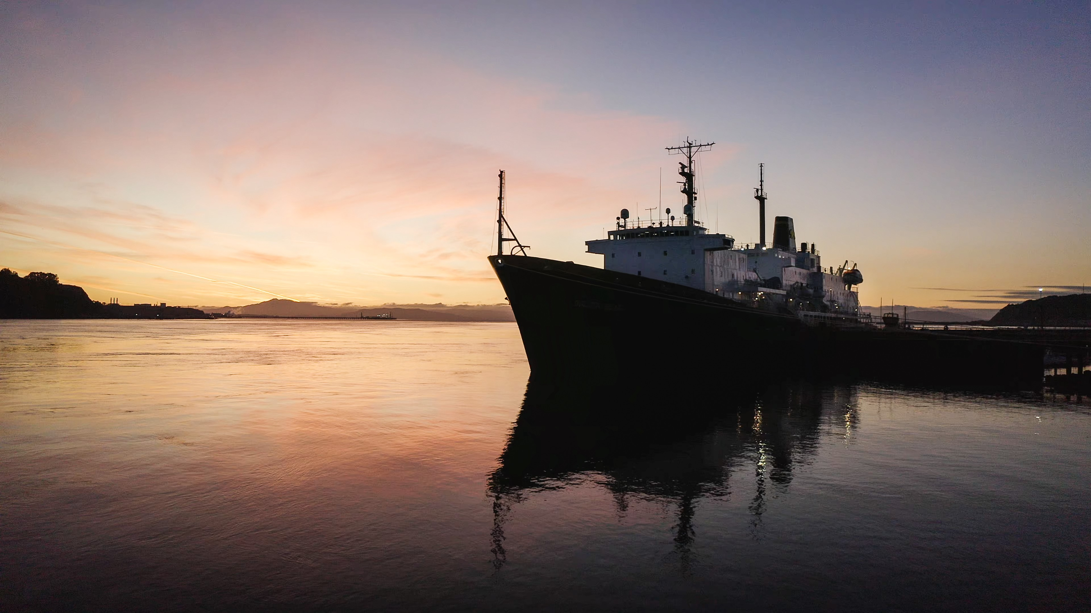

Make a 1-on-1 with a Career Coordinator
Ryan Rodriguez
rrodriguez@csum.edu
Ryan Scheidemantle rscheidemantle@csum.edu
Director
Lily Ploski
lploski@csum.edu
Admin Assistant
Tess Luna
tluna@csum.edu

Career Services
California State University Maritime Academy

