Newsletter from Career Services
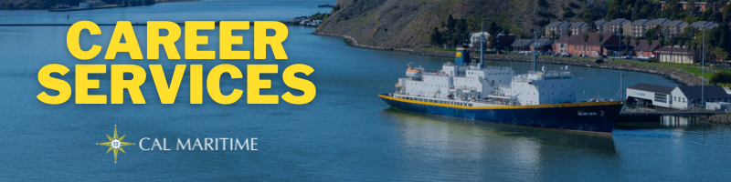
October 4th, 2021

Career Fair October 14th
Make sure you are ready for the Career Fair on October 14th. Check the uniform of the day. Do your research beforehand. Stop by Career Services to get any questions answered that you have and assistance in preparation. We currently have 69 companies signed up and excited to speak with our cadets!

On the Website
With the Fall Career Fair less than two weeks away, we have now posted the list of companies that will be attending. Please check this list out so you can zero in on the companies you would like to connect with. Also, check out the calendar of events on our webpage to see who, when, and where companies and organizations will be presenting.
Calendar of Events
Over the last month, Career Services interviewed cadets who completed their Co-Op this summer. The following majors had cadets interviewed: GSMA, ME, FET, IBL, and Oceanography. Watch these interviews to learn more about the various experiences and options available.
Watch Konnecting Keelhaulers on CS Page and YouTube

Appointments & Walk Ins
Career Services highly encourages you to stop by our offices, located in the Student Services Building, next to the quad. We take both appointments and walk ins, depending on what works with you and our schedule. Appointments in person are encouraged, but we can accommodate appointments via Zoom if that is your style.
Schedule an Appointment

Advice Section – Career Fair
With the Career Fair right around the corner, October 14th, we wanted to offer some tips in preparing for the Career Fair and to speak with recruiters. Foremost, make sure your resume is up to date. This includes any summer experiences like Bear Cruise, Co-Op, Sea Training II, or any other relevant summer experience. You can also add an on-campus job if you have started that. Stop by Career Services or shoot us an email if you want any feedback on your resume.
Updating your resume will help you two-fold at the Career Fair. First, it will ensure that you have an up-to-date document that you can pass onto recruiters. This allows recruiters to better understand the skills you could bring to their company or organization. Second, it serves as a good way to refresh on you past experiences, so you are ready to discuss them with recruiters. Being able to articulate your skills and accomplishments and how they fit into your career goals is key to marketing yourself.
Lastly, do your research prior to the Career Fair. There is a list of companies attending on the Career Services Events page to help you get started and come talk with our career coordinators for any help. You might not be able to answer every question about your career goals but showing knowledge of a company or organization as well as conveying your work skills and interests go a long way. Career Services is here to help you organize your thoughts and practice these conversations to you can enter the Career Fair with confidence.

Career Services Meetings
Sea Training II Career Conversations 10/5 – 10/7
October 21, 1100 – Compass Tuesdays – 1400 - Tech 104
Wednesdays – 1800 (Zoom) Thursdays – 1000 - Lab 201

Networking Opps

Career Fair
October 14th 0900 – 1400 in PEAC

Company Presentations
Lawrence Livermore National Lab 10/5 1100 – ABS 101
Crowley Shoreside 10/7 1100 – Virtual
Interlake Steamship 10/13 1730 – Student Services Building
Military Sealift Command 10/14 1600 – Student Services Building
Crowley Maritime 10/15 0900, 1000, 1100, 1300, 1400 – Student Services Building (sign up required)

NEW ON KCC
Bath Iron Works
Professional Development Program
2022 Summer Internship Program
Mellinger Engineering
Manufacturing Engineer/CNC Programmer
Phillips 66
2022 University Intern – Commercial Marine
Monterey Bay Aquarium
Facility Systems Supervisor
California Academy of Sciences
Planned Giving Coordinator
Automation Technician
Marina Realty
Office Assistant
Albertson’s Companies
Maintenance Superintendent
Distribution Center Industrial Engineer
Reverse Logistics Superintendent
Warehouse Supervisor
Find more jobs
Find more internships

Make a 1-on-1 with a Career Coordinator
Ryan Rodriguez
rrodriguez@csum.edu
Ryan Scheidemantle rscheidemantle@csum.edu
Director
Lily Ploski
lploski@csum.edu
Admin Assistant
Tess Luna
tluna@csum.edu

Career Services
California State University Maritime Academy

