Newsletter from Career Services
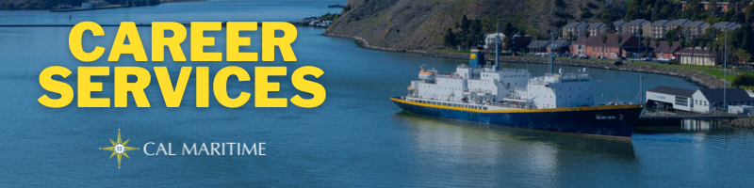
September 20th, 2021

Back in the Flow
Entering the 3rd week of classes, Career Services has been pretty busy so far. We are also starting to have events and workshop, in partnership with other stakeholders on campus, to bring you the most robust cadre of information possible concerning your career. We encourage you to attend our various events, but also stop by our offices to discuss your specific career path and questions. Don’t be a stranger!

On the Website
We are getting more companies signing up for company presentations as the semester swings into gear. Check out the calendar of events on our webpage to see who and where companies and organizations will be presenting.
Calendar of Events
This past week, Career Services recorded their first interview with cadets who completed their Co-Op this summer. This interview featured three GSMA cadets and can be found on both the Career Services webpage and the Cal Maritime YouTube page.
Watch Konnecting Keelhaulers on CS Page and YouTube

Appointments & Walk Ins
Career Services highly encourages you to stop by our offices, located in the Student Services Building, next to the quad. We take both appointments and walk ins, depending on what works with you and our schedule. Appointments in person are encouraged, but we can accommodate appointments via Zoom if that is your style.
Schedule an Appointment

Advice Section – On Campus Jobs
On campus jobs are a great way for you to get work experience and build your transferable skills. Just because an on-campus job is not in your area of study doesn’t mean that employers will not value the skills, such as written and oral communication, assertiveness, leadership, professionalism, and the ability to use technology, that you gain from an on-campus job. Each of these skills are fall under the career readiness competencies that employers are looking for in interns and recent graduates.
Furthermore, the ability to hold a job while also completing a demanding course load demonstrates your time management skills and ability to persevere through a demanding schedule. Both are skills that will be called upon time and again in both your internship and professional career. Building these throughout college allow you to hit the ground running in the professional workforce.
Lastly, on-campus jobs are also great ways for you to meet the staff and faculty on campus who can serve as both professional and personal mentors. Developing these relationships with mentors allows you to pick their brain on things to expect when you leave the college setting and enter the next phase of your life. As you traverse college and look to the future, mentors are there to assist you and help make your transitions easier.

Career Services Meetings
Sea Training II Co-Op Meetings
September 23, 1100 – Compass IBL
September 30, 1100 – Tech 146
FET/ME
September 30, 1130 – Tech 146
Career Conversations 9/14 – 10/7 Oceanography
Tuesdays – 1400 - Tech 104 September 30, 1100 – Tech 102
Wednesdays – 1800 (Zoom) GSMA
Thursdays – 1000 - Lab 201 September 30, 1130 – Tech 102

Networking Opps

Company Presentations Career Fair
BAE Systems 9/28 1100 – Virtual October 14th 0900 – 1400

NEW ON KCC
Bath Iron Works
Professional Development Program
2022 Summer Internship Program
Mellinger Engineering
Manufacturing Engineer/CNC Programmer
MAN Energy Solutions
Workshop – 1st Class Mechanic
ACCO Engineered Systems
Design Engineer
Chevron Phillips Chemical
GRAD – Sales/Commercial Trainee, Supply Chain Professional, Mechanical Engineer, Construction Specialist
Summer 2022 Intern – Construction Specialist, Mechanical Engineering, Supply Chain, Public Affairs
Chevron
Marine/Shipping Hull & Systems Engineer Intern
TESLA
Equipment Maintenance Technician Intern Fall 2021
Find more jobs
Find more internships

Make a 1-on-1 with a Career Coordinator
Ryan Rodriguez
rrodriguez@csum.edu
Ryan Scheidemantle rscheidemantle@csum.edu
Director
Lily Ploski
lploski@csum.edu
Admin Assistant
Tess Luna
tluna@csum.edu

Career Services
California State University Maritime Academy

