Newsletter from Career Services
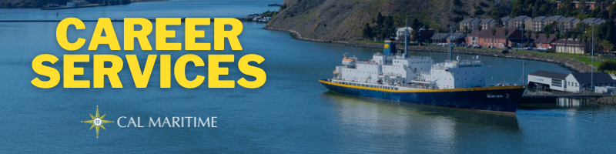
September 7th, 2021

Welcome Back
Career Services is excited to see our full Corps of Cadets back on campus after an unprecedented 18 months. There have been some changes in our office and on our website and we highly encourage you to stop by, check them out, and let us know how you’ve been. We look forward to conducting our larger group programing as well as answering more individual questions in 1 on 1 meetings.

On the Website
Several new features on our webpage that we want to direct your attention to. Found under the student’s tab, you can locate the career planning timeline, information on both Sea Training II and Cooperative Education, aka Internships, and each edition of this newsletter.
Student’s Tab
To stay up to date on all the events and networking opportunities Career Services offers, utilize the Career Services Events tab. Here, you will be able to see which companies and organizations are presenting on campus or virtually, the companies attending the Fall Career Fair, and each new edition of Konnecting Keelhaulers.
Career Services Events Tab

Appointments & Walk Ins
Career Services highly encourages you to stop by our offices, located in the Student Services Building, next to the quad. We take both appointments and walk ins, depending on what works with you and our schedule. Appointments in person are encouraged, but we can accommodate appointments via Zoom if that is your style.
Schedule an Appointment

Advice Section – Joining Clubs & Fall Applications
With school just beginning, there are many things on your mind as you start situating yourself for the semester. As you look towards an enriching semester, we want to remind you there are several things you can be doing early on that can enhance your resume and marketability when applying for internships and jobs.
Joining campus clubs is a great way to learn or sharpen skills that you will use in the workplace. Teamwork, leadership, communication, and problem solving are all highly valued by employers. Whether you are in a position of leadership or a club member, clubs offer you different opportunities that can further develop your soft skills. Furthermore, clubs can provide networking opportunities, especially if you are in professional orientated clubs that can be of great help when looking for internships and jobs.
The fall is also time to keep your eye open for internships and jobs. The summer may seem like the distant future, but some companies and organizations, particularly government agencies, large corporations, government adjacent companies, begin their recruiting processes in the fall. This is generally due to longer approval process or the need for specific clearances. If you are interested in any opportunities like this or want to learn more about what is on the market, stop by Career Services.

Career Services Meetings
Sea Training II Co-Op Meetings
September 23, 1100 – Compass IBL
September 30, 1100 – Tech 146
FET/ME
September 30, 1130 – Tech 146
Career Conversations 9/14 – 10/7 Oceanography
Tuesdays – 1400 - Tech 104 September 30, 1100 – Tech 102
Wednesdays – 1730 (Zoom) GSMA
Thursdays – 1000 - Lab 201 September 30, 1130 – Tech 102

Networking Opportunities

Company Presentations Career Fair
US Army Sept 15, 1100 – Tech 146 October 14, 0900 – 1400
Register Here

NEW ON KCC
TESLA
Equipment Maintenance Technician Internship Fall 2021
General Steamship Corp Ltd
Administrative Assistant
Vessel Manager/Boarding Agent
Chevron
Marine/Shipping Hull & Systems Engineer Intern
Marine/Shipping Hull & Systems Engineer
Flagship Management, LLC
12 positions – Engineering, Business Development, Deckies
IHI Power Service Corp
Energy Storage Technician
Washington State Ferries
On-Call Oiler (PT)
PORTS AMERICA
Superintendent – Auto/RoRo
Marine Advanced Robotics
Marine ASV Technician
Manufacturing Technician
Find more jobs
Find more internships

Make a 1-on-1 with a Career Coordinator
Ryan Rodriguez
rrodriguez@csum.edu
Ryan Scheidemantle rscheidemantle@csum.edu
Tess Luna
tluna@csum.edu

Career Services
California State University Maritime Academy

