How to Enroll in Direct Deposit
Steps for Student
- On csum.edu, Log into PeopleSoft – Student Systems, click Student Center
- Scroll down to the Finances section
- Click on the Enroll in Direct Deposit link

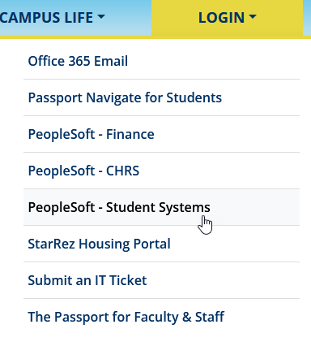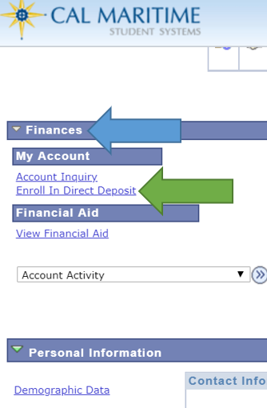

Please note, the Enroll In Direct Deposit feature will be disabled by I.T. on April 8th, 2024, to prevent fraudulent activity.

