TIME AND LABOR
QUICK REFERENCE GUIDE
FOR APPROVERS (Level One)
STEP 1: Access Approve Reported Time:  - Log in with your CMA User ID and Password  - Select Reported Time from the Manager Self-Service Center on the home page | 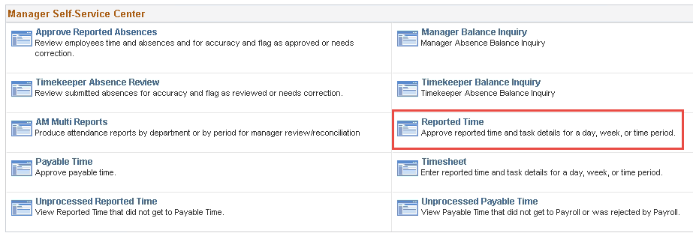
STEP 2: Get Employees:  - The View By will default to current week  - Add selection criteria such as Name, Empl ID, Department, or Position Number to retrieve specific employee(s)  - Change View By and Date  View By = All Time Before  Date = Pay Period End Date  Click  - Click on | 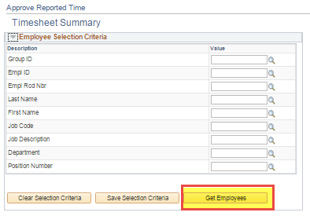  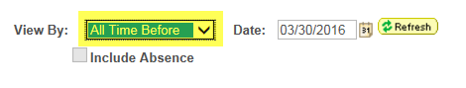
**PLEASE NOTE: CHANGE VIEW BY AND DATE**
View By = All Time Before
Date = Pay Period End Date then click
STEP 3: Select Employee(s) to Approve:  - Approve total hours by clicking “Select” box and Approve Selected.  - Or Click on name to review and approve by entry.  - Change View By in timesheet to “Time Period” to see all entries  - Select the entries to approve or checkto approve all.  - Then click on | 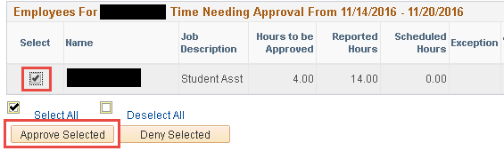  *** PLEASE NOTE***  If you need to make any adjustments to Timesheets after approval has been submitted refer to Correction Guide
STEP 4: Confirm Approvals:  - A Message will display click  - Save Confirmation message will display click | 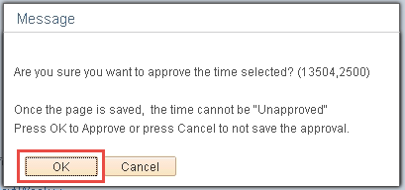 |  | 