TIME AND LABOR
QUICK REFERENCE GUIDE
FOR PAYABLE MANAGERS
STEP 1: Log into PeopleSoft and Access Approve Payable Time:  - Log in with your CMA User ID and Password  - Select Payable Time from the Manager Self-Service Center on the home page |  | 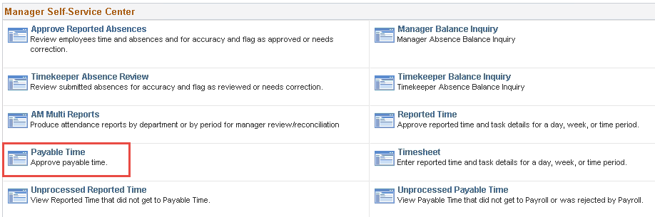
STEP 2: Get Employees:  **please note that entries that have not been approved by the First Level will not appear in your approval list.  - Add selection criteria such as Name, Empl ID, Department, or Position Number to retrieve specific employee(s). OR  - Leave search criteria fields blank to retrieve a list of all employees.  The Start and End Dates appear at the bottom of the page and default to current week.  - Change the date to the beginning and end of the Pay Period. Click on Refresh  - Click on |  | 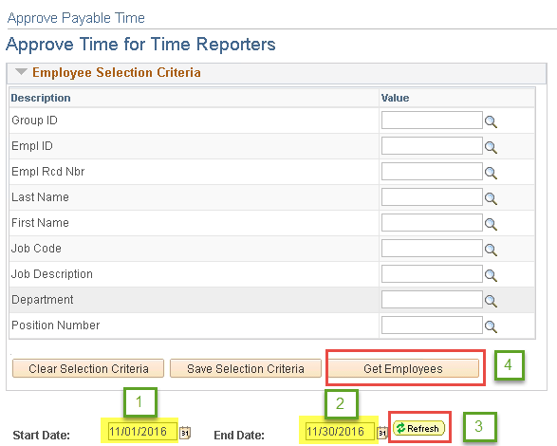
STEP 3: Select Employee(s) to Approve:  - Click on the box next to employee(s) name OR click link  to approve all employees  - Then click on  - To review or see details for a specific employee, click on the name and click Adjust Reported Time hyperlink.  - Change the View By to Time Period to see the whole period. |  | 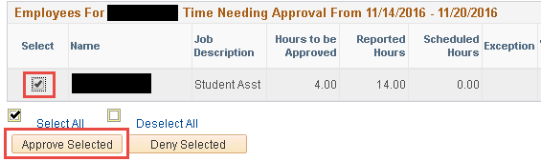  ***PLEASE NOTE**  If you need to make any adjustments to Timesheets after approval has been submitted refer to Correction Guide
STEP 4: Confirm Approvals:  - A Message will display click  Save Confirmation message will display click |  | 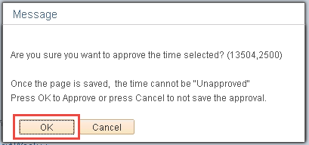 |  | 